**Cheapest Home decor Ideas which will be always Trendy**

By Hania Hareem

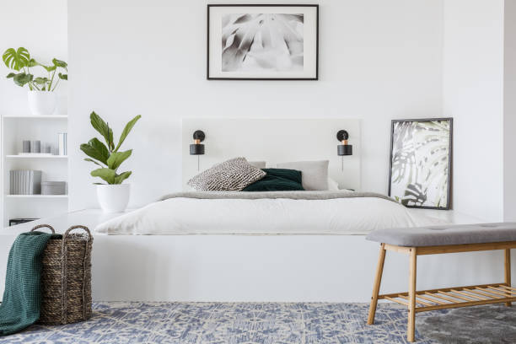

You want to make your living space peaceful, classy but in an affordable way. Here we have a solution for you, timeless ideas which will make your space look wider, and breathable.

**More Windows, More light**

Always try to have more windows bigger in size instead of huge walls. Beside giving you a fresh dose of air and sunlight, it moderates the temperature of the house. Also, you have a great option for changing the colours of curtains and adding new dimensions to your room in order to avoid those dull looks. The base areas of windows can be utilized for placing plant pots.

**Redecorate Your Wall Hangings**

You can give a new life to old wall hangings by recoating them with leftover paints and can add more textures on them. You can also paint mud pots and old toys made up of wood, plastic or metal to add as budget friendly home decor pieces.

**Revamp your Antiques**

This is a great way to cherish your old day’s memories and remember your older ones by giving a makeover to the old unused things from your store. You can turn your old radio piece or kettle of your grandmother into a handmade decor piece by giving it a spray paint. Similarly, you can use old furniture by painting in a trendy color, changing its handles and turning it into a new product.

**Turn Coloured Prints into Paintings**

Here is the cheapest way to decorate your house. If you are a painting enthusiast you can get a high-resolution painting or picture for instance of swords, or forest and get it framed after printing. your desire and home’s need both will be satisfied this way.

**Lamps and Vases**

Lamps, vessels and bases must be present in your list of home decor ideas in the living room. They are the cheapest source to add fragrance, colours and light at your place giving peace to your mind as well. The greenery in those vases gives a relaxation with adding a vibe which is the need as nowadays more time is spent at home.

**Scented Candles**

Scented candles available in different flavors, notes and colors can surely elevate vibe of your home. They prove not only uplift your mood through your favorite fragrances, but also help you to feel calm and relax. They also have a health benefit while turning your anxiety into positive emotions.

Don’t you think these cheapest ways are the need of an hour in these tough times and by adopting these you can turn your place into a cool one. Remember these are budget friendly and will never go out of the fashion.