**Is Ai your New Dermatologist?**

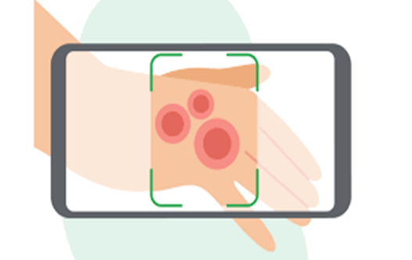

Artificial Intelligence (AI) has revolutionized every field and created many concerns with much ease. Are you aware that AI, after taking away the jobs of engineers, software experts, content writers, video editors is ready to conquer the field of medicine.

**Precise and Early Diagnosis**

Now, you can check your skin’s condition, underlying skin cancers, and other skin issues through your mobile phone’s screen, thanks to AI. This tool will learn your skin’s history through dermoscopic images and will provide you with accurate results, sometimes better than humans. It has an ability to diagnose the condition whether moles and lesions or serious conditions like acne, eczema, or psoriasis, precisely. It can prove beneficial in early diagnosis of fatal diseases like skin cancer.

**Free Prescription**

In addition to examining your skin type, conversational AI can provide you with free and valuable advice. It will recommend you the right *tailored skincare solutions with* the right products and routines. It is an obvious that it works on an algorithm, so will provide you with more filtered results having better reviews and ratings.

**Reminders through Apps**

Along withother apps in the market, Dermatology AI Apps are also growing in popularity. Various dermatology apps are already in the marketplace which can give instant analysis, and even track skincare progress. These *pocket dermatologists* are easy to access and are much cheaper than clinicians.

**Research and Common Knowledge**

This opportunity has not only widespread the information about skin’s problems and solutions but also enhanced research trends. Every expert or skin specialist would try to stay more aware about latest researches, as the common man has an access and can cross-check or verify the results.

**Available at all Time**

This is not like a doctor who asks for appointments in advance or displays a timing board outside the clinic. It is available to address your skepticism and doubts at any hour of the night or day. So, you do not have to worry for waiting rooms or scheduling hassles. Get expert advice at your convenience at any time.

**Modified and Updated Data**

This online dermatologist has the ability to continuously update and modify its data according to requirements and the environment. Therefore, this feature allows to give more better results, hence satisfying the patients.

**Final Thoughts**

No doubt AI will definitely help in getting diagnoses and treatments at much cheaper rates and in the convenience of your own place, however human hand and compassion remain necessary. A Human doctor can more easily interpret the emotional state of a patient and can treat accordingly. Similarly, virtual examination and consultation of your whole body may not be suitable for everyone. Dermatologists should certainly use artificial intelligence to enhance their practices and to become more search-oriented.